
Year 11 Essentials

2019 Test 4

Perimeter, Area, Mass, Volume and Capacity

Resources allowed: Calculator and 1 x A4 page one side
Name: ________________

Show all working out for full marks | Total: /45  Time: 45 mins

- [6 marks]
Convert the following

- 56cm =___________mm  - 3600m= __________km  - 3.4$cm^{2}$= ___________$mm^{2}$ | - 500ml=______l  - 634$cm^{3}$=_______ml  - 580g=_________kg

- [2 Marks]
If you have a 2.5m piece of wood, and you needed 6 pieces cut, estimate how long should each piece be? (nearest 10cm)

- [3 marks]
If a room is 7.2 metres long, and 5.9 meters wide, estimate how big is the room is to the nearest square meter? (hint- draw a diagram and don’t give exact answer)

- [2 marks]
Find the perimeter of the following shapes

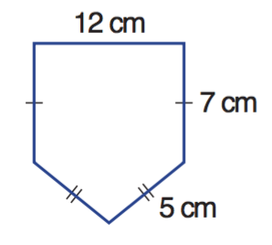
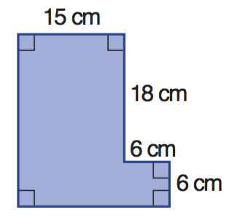
a b

P =____________________ P =____________________

- [8 marks]
Use the following table to convert these imperial units to metric

IMPERIAL | METRIC
1 inch | 2.54cm
1 foot | 30.4cm
1 yard | 91.44cm
1 mile | 1.609km

- 40 feet to meters

- 30 inches to centimetres

- 65 metres to yards

- 60 miles to Kilometres

- [7 marks]
Find the Area of the following
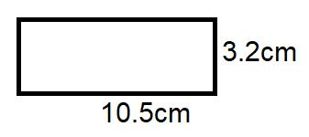 | 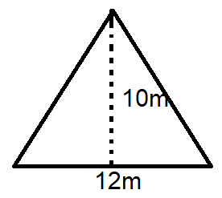
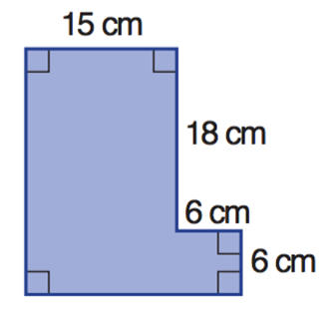

- [5 marks]
Jack is tiling his bathroom floor with 12cm by 12 cm tiles.
- Find the area of floor that needs to be tiled  - Find the area of each tile  - How many tiles will Jack need to tile the bathroom? | 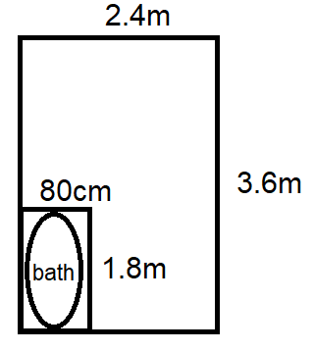

- [4 marks]
25L of water is poured into a rectangular fish tank, which is 50cm long, 20cm wide and 20cm high. Will it overflow?

- [2 marks]
A pack of 500 sheets of paper has a mass of 2.5kg. find the mass of one sheet of paper, giving your answer in the most appropriate unit.

- [6 marks]
A farmer is building a fence around his horse paddock. The paddock has an area of 2 hectares.

- If the length of the paddock is 125m, what is the width?

- What length of fencing will be required to fence the entire horse paddock?

- If the fencing costs $6/m, how much will it cost to fence the paddock?

End of test

